The Seventh International Scientific – Training Conference “Interdisciplinary Aspects  of Beauty, Health and Disease”  Jarosław, May 15th, 2019 | 

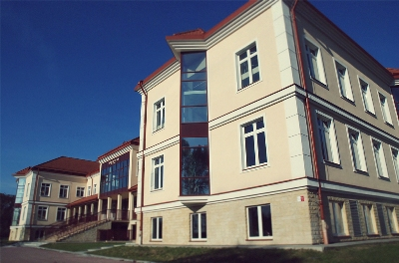  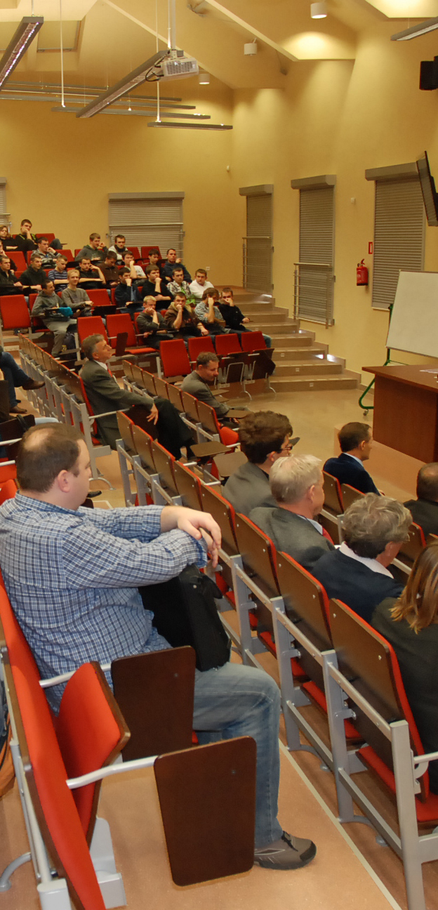  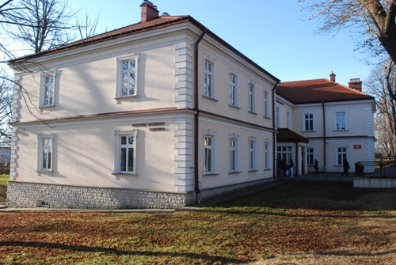  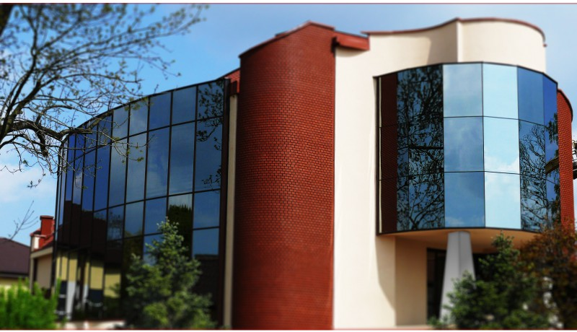 |  | Dear Colleagues,  On behalf of the Scientific Committee of the Conference I have a pleasure to invite you to take part in the seventh International Scientific – Training Conference “Interdisciplinary Aspects of Beauty, Health and Disease”. The Conference will take place on May 15, 2019 in the Library of the Bronisław Markiewicz State Higher School of Technology and Economics in Jaroslaw (Czarnieckiego 16 Street).  The Conference is primarily aimed at group of the following professionals: cosmetologists, nurses, midwifes, social workers, paramedics, dietitians, medical doctors and students. We also extend invitation to representatives of other disciplines: philosophers, sociologists, psychologists and educators for presentation and discussion.  The participants of the Conference will have an opportunity to exchange opinions, experiences and share scientific achievements. We hope that taking part in the sixth International Scientific Conference will allow the participants to broaden their knowledge, develop international scientific collaboration as well as vocational education and training.  We kindly invite you to take part in the Conference.  Respectfully yours,  Jarosław Noworól, PhD  Director of the Health Care Institute, PWSTE  Agenda and sessions  - Contemporary Nursing in European and global dimension: prospects for development in face of current patient and community needs, healthcare providers and nursing students.  - Woman’s and Family care.  - New trends in Cosmetology and Aesthetic Medicine.  - Social Work in the perspective of the 21st Century.  - Public Health – the interdisciplinary dimension.  - Young Scientists session.  - Poster session.
 | The Conference fee:  - Payment for participation in the conference (1 day) : 120.00 PLN  - Payment for students and doctoral students: 60.00 PLN  The fee includes:  -participation in the scientific sessions and workshops  -Conference materials  -Certificate of participation with educational points  -lunch  -coffee brakes and refreshments.  - Gala dinner fee is 100 PLN  - The fee for publication in the monograph is 200.00 PLN  Important Dates:  • General participation registration deadline, including sending abstracts is April 15th, 2019 (the Card of active participation and summary of the paper in English and Polish).  The Organizing Committee provides the active participants with technical services (multimedia projector, poster stands) and publication of articles in conference materials. The speakers are asked to make presentations in Polish and English.  • The deadline for sending a full paper text for monograph publication is May 30th, 2019.  • The deadline for passive participants registration is May 6th, 2019 (the Card of passive participation).  The condition of the conference participation is completion and sending of the registration form as well as paying the charge for participation in the conference.  Terms of publication:  Selected papers will be published in scientific monograph in Polish (the editorial requirements are available in the attachment).  Bank account number:  Państwowa Wyższa Szkoła Techniczno-Ekonomiczna w Jarosławiu  ul. Czarnieckiego 16, 37-500 Jarosław  Bank account number: 75 1500 1634 1216 3005 4488 0000  Title: Name – International Conference IOZ 2019  Organizers:  The Bronisław Markiewicz State Higher School of Technology and Economics in Jaroslaw, Poland  Villanova University, Villanova, Pennsylvania, USA  Catholic University in Ružomberok Faculty of Health, Słovakia  The Zhytomyr Nursery Institute, Ukraine  Bukovinian State Medical University, Ukraine  „Cooperativa SONDA”, Altivole TV, Włochy  Secretariat of the Conference  Ewelina Kucab-Górska  Health Care Institute, PWSTE  Czarnieckiego 16 Street, 37-500 Jarosław  e-mail: konf.ioz@pwste.edu.pl  tel/fax: 16 624 46 03 |  | 